Membership Application

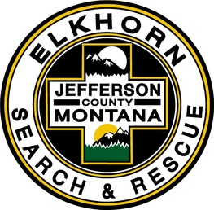 Elkhorn Search & Rescue

PO Box 342, 4 Railroad Way, Clancy, MT 59634

Name: Date:
Address:
Primary Phone: Work Phone:
Email:
DOB:
Occupation: Employer:
Employer Address:
Number of Years in Jefferson County:
Nearest Relative: Relationship:
Address: Phone:

Will employer release you for Search and Rescue missions?

Please list any equipment or specialized skills you may have:

Do you have current insurance on vehicle(s) you will use on ESAR missions and activities?

Signature Date

Member Release Form

Elkhorn Search & Rescue

PO Box 342, 4 Railroad Way, Clancy, MT 59634

I, , hereby authorize the Jefferson County Sheriff’s Department to conduct a background investigation for any criminal history or other information concerning my moral character.

I hereby release the Jefferson County Sheriff’s Department from any liability for any damage that may result from this investigation.

Date: Signature:
Print Full Name:
Current Address:
Date of Birth:

